YouSaveIt WEBSITE

Proposal Document



**­TEAM: EAGLE**  
**Cycle 2 - V.1.1**

**Revision History**

|  |  |  |  |
| --- | --- | --- | --- |
| **Date** | **Version** | **Description** | **Custodian/Organization** |
| 13/08/2013 | 1.0 | Initial publication. | EAGLE TEAM |

###### Table of Contents

1. Introduction 2

1.1 Purpose 2

1.2 Definitions, acronyms, and abbreviations 2

1.3 Project scope 2

1.4 References 2

1.5 Intended Audience and Reading Suggestions 3

2. General Description 4

2.1 Website Context Diagram 4

2.2 Product functions 4

2.2.1. Function’s priorities 4

2.2.2. Function list 5

2.3 User characteristics 6

2.4 Operating environment 6

3. Use case diagram 8

4. Use case specification 10

4.1 Use case list 10

4.2 Use case detail 11

4.2.1. Use case Add comment 11

4.2.2. Use case Delete comment 12

4.2.3. Use case Change information 14

4.2.4. Use case Send request 15

4.2.5. Use case Edit request 17

4.2.6. Use case Delete request 18

Appendix A: Approval 20

# Introduction

## Purpose

The software requirements specification document describes the essential behavior of a website from a user's point of view. The complete description of the functions to be performed, provide a basis for developing the website design

Additionally this document describes the non-functional requirement, constraints, and other factors necessary to provide a complete, comprehensive description of the website requirement.

A complete and correct SRS reduces effort wasted on redesign, recoding and retesting.

## Definitions, acronyms, and abbreviations

|  |  |  |
| --- | --- | --- |
| **No.** | **Acronyms** | **Definitions** |
| 1 | RAD | Requirement Analysis Document |
| 2 | RED | Requirement Elicitation Document |
| 3 | SRS | Software Requirement Specification |
| 4 | IEEE | Institute of Electrical and Electronics Engineers |

## Project scope

This project builds a website that its purpose is to swap the item between the members. Developing the functions module topic, search function, register function, login/logout, send swap request function, consignment module, and admin control panel, evaluate user account, user control panel.

## References

* IEEE STD 830 - 1998 I EEE Recommended Practice for Software Requirements Specifications. IEEE Computer Society, 1998
* [Eagle] Software Requirement Specification Document Cycle 1

## Intended Audience and Reading Suggestions

**The second part**, the Overall Description section, this part gives an overview of the functionality of the product. It describes the informal requirements and is used to establish a context for the technical requirements specification in the next part.

**The third part**, Requirements Specification section, this document is written primarily for the developers and describes in technical terms the details of the functionality of the product.

**The next part**, analysis model will allow understand detailed function. How to it implement in this website.

All sections of the document describe the same website in its entirety, but are intended for different audiences and thus use different language.

# General Description

## Website Context Diagram

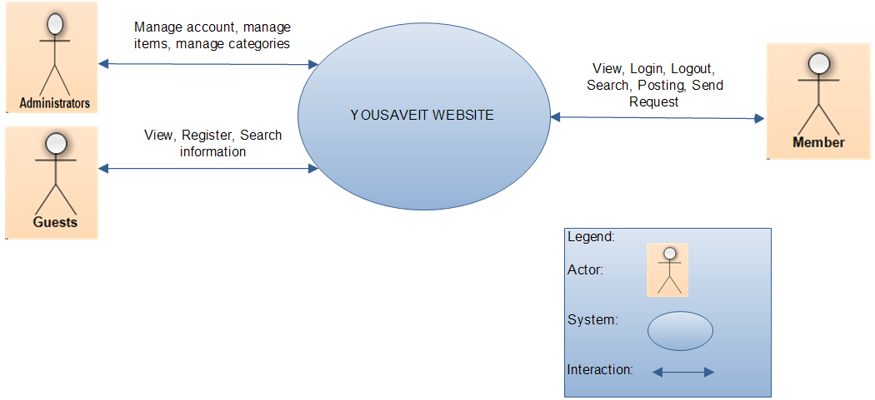

*Figure 1: Website context diagram*

## Product functions

### Function’s priorities

Below is a list of all functions that can be found in the website with a description of the function and its priority. The priorities range from 1 to 3 with 1 being the highest priority and 3 being the lowest.

*Table 1: Function’s priorities range*

|  |  |
| --- | --- |
| **Priority** | **Detail** |
| 1 | Must have |
| 2 | Should |
| 3 | Nice to have |

### Function list

*Table 2: Function list*

|  |  |  |  |
| --- | --- | --- | --- |
| **ID** | **Name of Main Function** | **Description** | **Priority** |
| F01 | Register | This function is register to create a new account when they want to become a member uses the other functions of website by rules. | 1 |
| F02 | Login /Logout | This function is used for website’s member and administrator to login/logout to the website. | 1 |
| F03 | Posting management | This function is to give information about the items that they want to exchange. | 1 |
| F04 | Search | This function allows the user to search by category | 2 |
| F05 | Comment | This function allows user to comment on topic | 3 |
| F06 | Request management | This function allows user to send, edit, delete request swap item between them | 1 |
| F07 | User control panel | This control panel allows user to manage their topic, request, and their information. | 1 |

## User characteristics

*Table 3: The following is a list of the actors in the website and their description.*

|  |  |
| --- | --- |
| **Actors** | **Descriptions** |
| Administrators | Manage the whole website, grant permission, confirm, and update the information. |
| Member | Who registered account; this person has the right to use the post function, comment function. |
| Guest | Who can visit the website, search information |

## Operating environment

*Table 4: Operating environment*

|  |  |  |  |
| --- | --- | --- | --- |
| **Operating Website** | **Feature** | **Minimum Required** | **Recommended** |
| Hardware | CPU | 1x Intel® Xeon® Sandy  Bridge Quad-Core E3-1220  2.20GHz 8MB 1GB RAM | Configurable: 1x Intel®  Xeon® Westmere Quad  Core Processor E5620,  3.40GHz, 12M  Configurable 4GB RAM |
| Software | Browser | Google Chrome | Firefox, Internet Explorer |
| OS | CentOS 32bit | Recommended: CentOS  64bit  Optional: Ubuntu,  Debian, Fedora (32bit or  64bit) |
| Hosting | Bandwidth | 300GB/month | Expandable 1TB/month |
| PHP | Version 5.1 |  |
| MySQL |  |  |
| PHPMyadmin |  |  |
| Apache |  |  |

# Use case diagram

*Table 5: Legend of use case diagram*

|  |  |  |
| --- | --- | --- |
| **Construct** | **Description** | **Syntax** |
| Use case | A sequence of actions, including variants, that a website (or other entity) can perform, interacting with actors of the website. |  |
| Actor | A coherent set of roles that users of use cases play when interacting with these use cases. |  |
| Website boundary | Represents the boundary between the physical website and the actors who interact with the physical website. |  |
| Relationship | Relationship between use case |  |

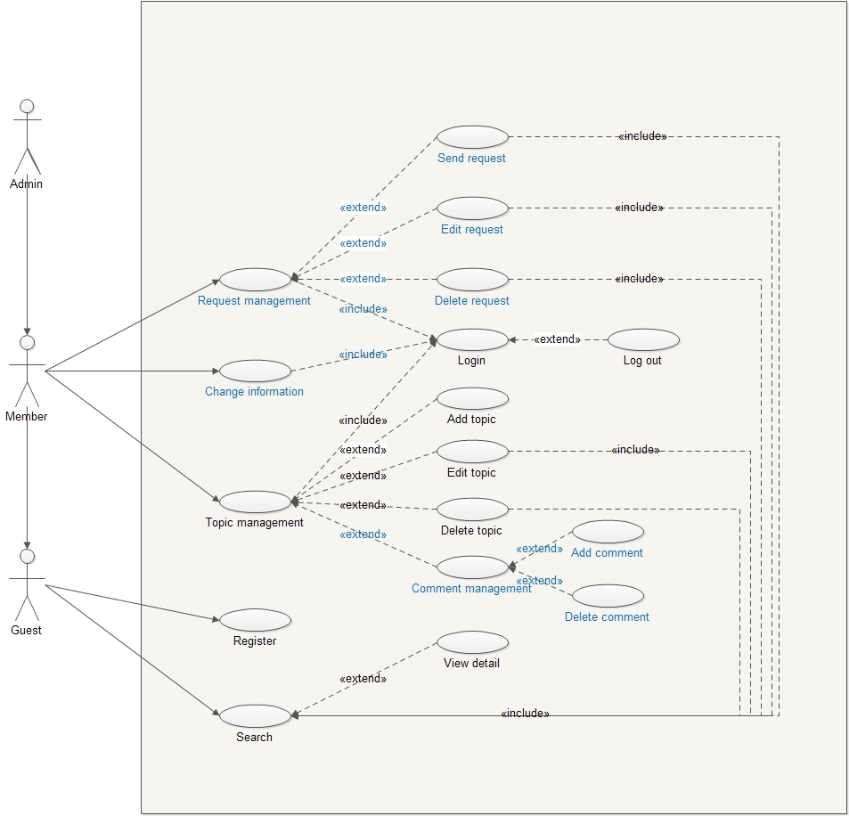

*Figure 2: Use case overview*

# Use case specification

## Use case list

*Table 6: Use case list*

|  |  |  |
| --- | --- | --- |
| **Use case ID** | **Use case name** | **Note** |
| UC01 | Register |  |
| UC02 | Login |  |
| UC03 | Logout |  |
| UC04 | Add post |  |
| UC05 | Edit Post |  |
| UC06 | Delete post |  |
| UC07 | Search |  |
| UC08 | View detail |  |
| **UC09** | **Add comment** |  |
| **UC10** | **Delete comment** |  |
| **UC11** | **Change information** |  |
| **UC12** | **Send request** |  |
| **UC13** | **Edit request** |  |
| **UC14** | **Delete request** |  |

## Use case detail

### Use case Add comment

*Table 7: Use case Add comment detail*

|  |  |  |  |  |
| --- | --- | --- | --- | --- |
| Use Case ID | UC09 | | | |
| Use Case Name | Add comment | | | |
| Create by | Phuong Trinh | | Last Updated By | Phuong Trinh |
| Date Created | 30/9/2013 | | Date Last Updated | 30/9/2013 |
| Actor | Administrator  Member  Guest | | | |
| Description | This function is allow user to comment on the topic by their Facebook account | | | |
| Trigger | 1. Comment | | | |
| Precondition | 1. User already login on Facebook | | | |
| Post condition | 1. User’s comment will display in topic detail | | | |
| Normal flow | Add comment | | | |
| Step | Description | | |
| 1 | At home page website, click on title of topic | | |
| 2 | The topic detail is display | | |
| 3 | User enter their comment on Facebook textbox | | |
| 3 | User submit their comment | | |
| 4 | The end | | |
| Alternative Flow | 1 | User enter keyword on search textbox | | |
| 2 | User click button search | | |
| 3 | Result is display | | |
| 4 | User click on title of topic | | |
| 5 | The detail of this topic will display | | |
| 6 | User enter their comment on Facebook textbox | | |
| 7 | User submit their comment | | |
| 8 | The end | | |
| Exceptions | N/A | | | |
| Includes | UC08 | | | |
| Extend | N/A | | | |

### Use case Delete comment

Table 8: Use case Delete comment detail

|  |  |  |  |  |
| --- | --- | --- | --- | --- |
| Use Case ID | UC10 | | | |
| Use Case Name | Delete comment | | | |
| Create by | Phuong Trinh | | Last Updated By | Phuong Trinh |
| Date Created | 30/9/2013 | | Date Last Updated | 30/9/2013 |
| Actor | Administrator  Member  Guest | | | |
| Description | This function is allow user to comment on the topic by their Facebook account | | | |
| Trigger | 1. Comment | | | |
| Precondition | 1. User already login on Facebook 2. User’s comment want to delete already exist | | | |
| Post condition | 1. User’s comment will display in topic detail | | | |
| Normal flow | Delete comment | | | |
| Step | Description | | |
| 1 | At home page website, click on title of topic | | |
| 2 | The topic detail is display | | |
| 3 | User find Facebook comment they want to delete | | |
| 4 | User submit | | |
| 5 | The end | | |
| Alternative Flow | 1 | User enter keyword on search textbox | | |
| 2 | User click button search | | |
| 3 | Result is display | | |
| 4 | User click on title of topic | | |
| 5 | The detail of this topic will display | | |
| 6 | User find Facebook comment they want to delete | | |
| 7 | User submit | | |
| 8 | The end | | |
| Exceptions | N/A | | | |
| Includes | UC08 | | | |
| Extend | N/A | | | |

### Use case Change information

*Table 9: Use case Change information detail*

|  |  |  |  |  |
| --- | --- | --- | --- | --- |
| Use Case ID | UC11 | | | |
| Use Case Name | Change information | | | |
| Create by | Phuong Trinh | | Last Updated By | Phuong Trinh |
| Date Created | 30/9/2013 | | Date Last Updated | 30/9/2013 |
| Actor | Administrator  Member | | | |
| Description | This function is allow user to change their information | | | |
| Trigger | 1. Change information | | | |
| Precondition | The user had to log into the website | | | |
| Post condition | If Use case is successful, the information of user will be change | | | |
| Normal flow | Step | Description | | |
| 1 | User click on “Control panel” on navigation, choose tab “My profile” | | |
| 2 | User change their   * Avatar * Email * Name * Address * Phone | | |
| 3 | User click button “Update” | | |
| 4 | The end | | |
| Alternative Flow | N/A | | | |
| Exceptions | N/A | | | |
| Includes | UC02 | | | |
| Extend | N/A | | | |

### Use case Send request

*Table 10:* *Use case Send request detail*

|  |  |  |  |  |
| --- | --- | --- | --- | --- |
| Use Case ID | UC12 | | | |
| Use Case Name | Send request | | | |
| Create by | Phuong Trinh | | Last Updated By | Phuong Trinh |
| Date Created | 30/10/2013 | | Date Last Updated | 30/10/2013 |
| Actor | Administrator  Member | | | |
| Description | This function is allow user to send request for swap item | | | |
| Trigger | 1. Send request | | | |
| Precondition | User had login in website | | | |
| Post condition | The information about their item used to swap will send to the author | | | |
| Normal flow | Step | Description | | |
| 1 | At home page website, click on title of topic | | |
| 2 | The topic detail is display | | |
| 3 | User click button “Request” | | |
| 4 | User input information about their item in the form | | |
| 5 | User click button “Create Request” | | |
| 6 | The end | | |
| Alternative Flow | 1 | User enter keyword on search textbox | | |
| 2 | User click button search | | |
| 3 | Result is display | | |
| 4 | User click on title of topic | | |
| 5 | The detail of this topic will display | | |
| 6 | User click button “Request” | | |
| 7 | User input information about their item in the form | | |
| 8 | User click button “Create Request” | | |
| 9 | The end | | |
| Exceptions | N/A | | | |
| Includes | UC02 | | | |
| Extend | N/A | | | |

### Use case Edit request

*Table 11: Table Use case Edit request detail*

|  |  |  |  |  |
| --- | --- | --- | --- | --- |
| Use Case ID | UC13 | | | |
| Use Case Name | Edit Post | | | |
| Create by | Phuong Trinh | | Last Updated By | Phuong Trinh |
| Date Created | 30/10/2013 | | Date Last Updated | 30/10/2013 |
| Actor | Administrator  Member | | | |
| Description | This function is allows user to change their swap information | | | |
| Trigger | 1. Change swap information | | | |
| Precondition | * User had login on website * Request existed in website | | | |
| Post condition | Request information will be change | | | |
| Normal flow | Step | Description | | |
| 1 | User click “Control panel” on navigation | | |
| 2 | Choose tab “My request” | | |
| 3 | Find request want to edit | | |
| 4 | Click button “Edit” | | |
| 5 | Change the information on the form | | |
| 6 | Click button “Update” | | |
| 7 | The end | | |
| Alternative Flow | 1 | User click topic on the Home page | | |
| Exceptions | N/A | | | |
| Includes | UC02 | | | |
| Extend | N/A | | | |

### Use case Delete request

*Table 12: Table use case delete request detail*

|  |  |  |  |  |
| --- | --- | --- | --- | --- |
| Use Case ID | UC14 | | | |
| Use Case Name | Delete request | | | |
| Create by | Phuong Trinh | | Last Updated By | Phuong Trinh |
| Date Created | 30/10/2013 | | Date Last Updated | 30/10/2013 |
| Actor | Administrator  Member | | | |
| Description | This function is allows user to delete request information | | | |
| Trigger | 1. Delete request information | | | |
| Precondition | * User had login on website * Request existed in website | | | |
| Post condition | The request information will be deleting. | | | |
| Normal flow | Step | Description | | |
| 1 | User click “Control panel” on navigation | | |
| 2 | Choose tab “My request” | | |
| 3 | Find request want to edit | | |
| 4 | Click button “Delete” | | |
| 7 | The end | | |
| Alternative Flow | N/A | | | |
| Exceptions | N/A | | | |
| Includes | UC02 | | | |
| Extend | N/A | | | |

# Appendix A: Approval

|  |  |  |
| --- | --- | --- |
| **Prepared by** | **Signature** | **Date** |
| Tran Cong Binh  K16CMU-TTT | | |
| **Approved by** | **Signature** | **Date** |
| Tran Kim Sanh  Mentor  Duy Tan University | | |
| Nguyen Trinh Trung Duong  Mentor  Duy Tan University | | |